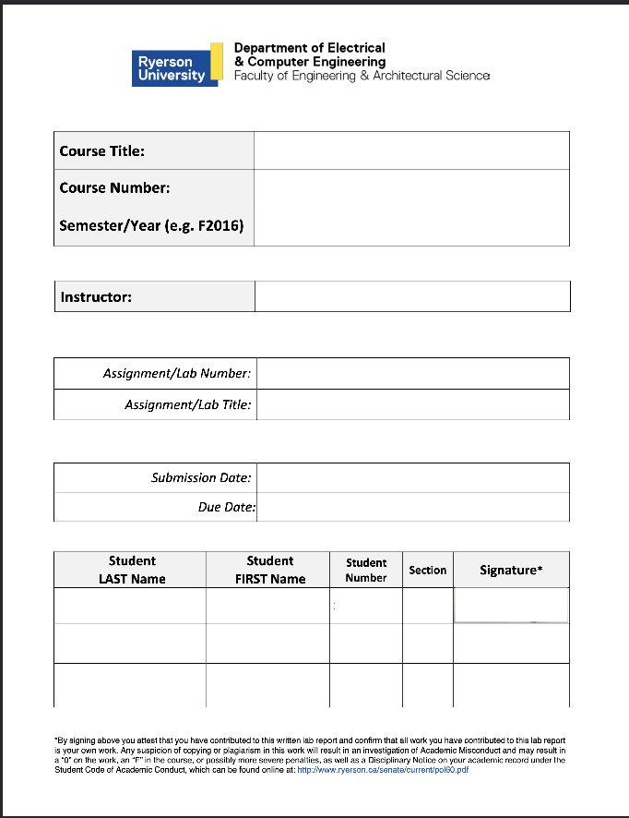
Electronic Circuits 1

P2024
Jassar, Surinder
5
CB Amplifier
June 14, 2024
June 14, 2024
Mourad Shai
04
501170415
Sharma
Tanishq
501122854
04
TS
Table of Content
1. Introduction...........................................................................................R2
2. Objectives..............................................................................................R2
3. Circuit under Test..................................................................................R2
4. Experimental Results............................................................................R3
5. Conclusions and Remarks.....................................................................R4
6. Appendix: Signed Pre-Lab and TA Copy of Results...............................R5

Introduction

The report for Lab 6, CB Amplifier, is presented here. This lab took place on June 11, 2024. The TA’s signed copy and the pre-lab are included in Appendix.

Objectives
The objective of this lab was to investigate and examine Common-Emitter Amplifiers and bias a BJT in active mode. Through this we will learn a technique for experimental evaluation of input and output resistances of amplifiers. The circuit provided in the lab manual was built and results were found using an oscilloscope, voltage source, and ammeter.

Circuit under Test
The Circuits below were used for the prelab
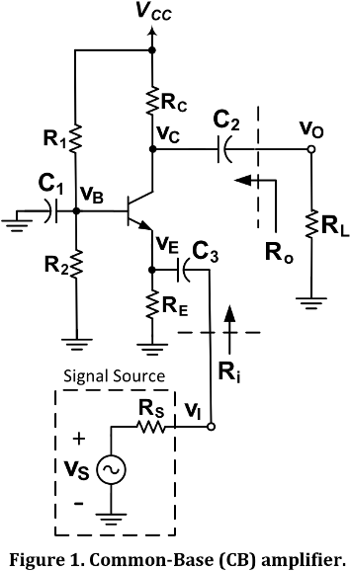

Experimental Results
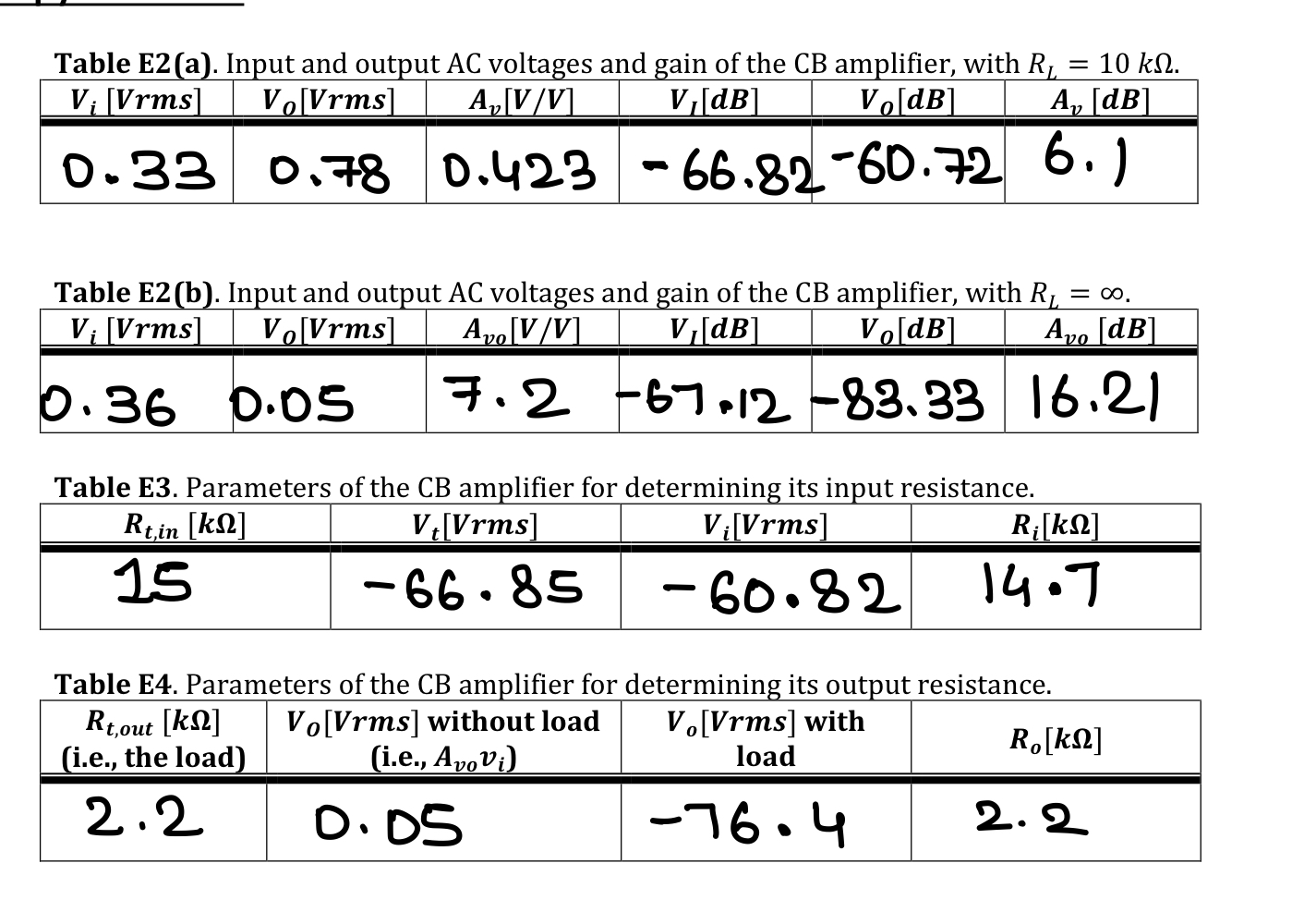

Conclusion and Remarks:
C1:
Table C1. Calculated and measured AC parameters for CB amplifiers of Figure 1.
 | A_{v} [V/V] | A_{Vo} [V/V] | R_{i} [kΩ] | R_{o} [kΩ]
Calculate Values (Table P1(b)) | 147.84 | 12.0.96 | 14.7 | 2.2
Measure Values  (Tables E2, E3, and E4) | 0.423 | 7.2 | 15 | 2.2
Percent Error, 𝑒 % | 99.71 | 94.05 | 2.04 | 0.00

The errors for A_{V}​ and A_{Vo}​ are extremely high, likely due to model assumptions, parasitic elements, measurement inaccuracies, component variability, and loading effects. In contrast, the errors for R_{i}​ and R_{o}​ are minimal, indicating better agreement between theoretical and practical values for resistance. This highlights the complexities of accurately predicting gain in real-world circuits compared to resistance.

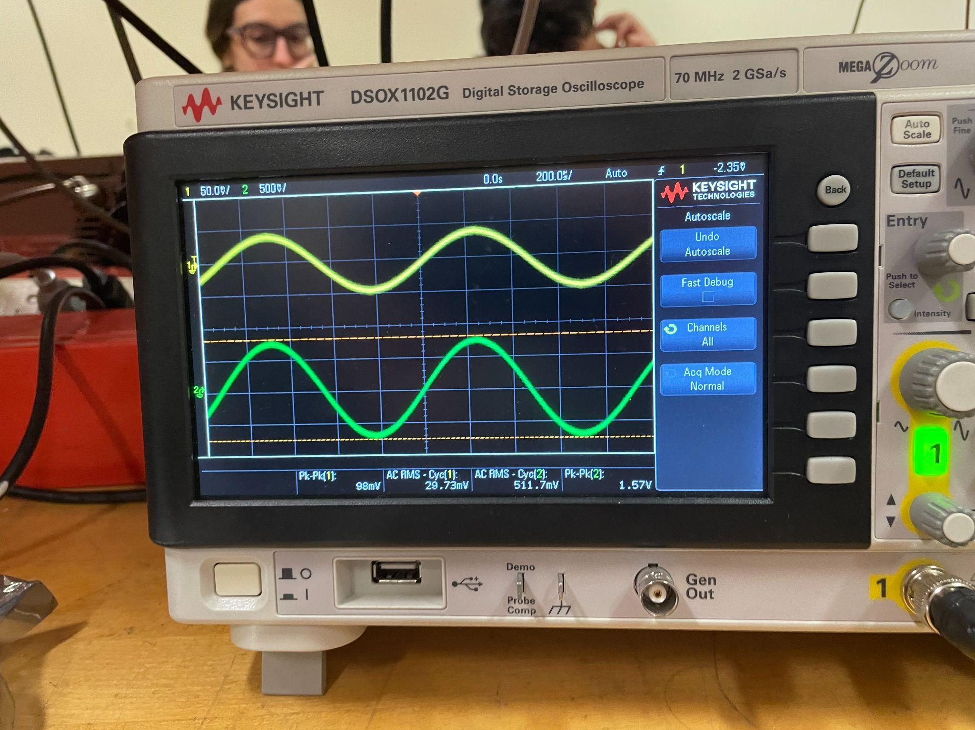
Graph E2. Vi and Vo waveforms for circuit Figure 1.

C2:

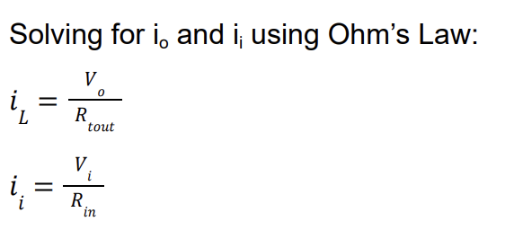

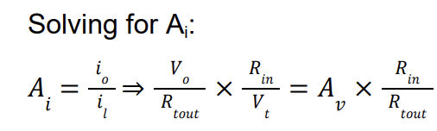
= $0.423\frac{V}{V}* \frac{15kΩ}{2.2kΩ} =2.884\frac{A}{A}$

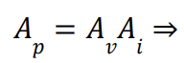
= $0.423\frac{V}{V}*2.884\frac{A}{A} = 1.220 \frac{W}{W}$

Therefore: A_{i} = $2.884\frac{A}{A}$ and A_{p} = $1.220 \frac{W}{W}$

Appendix: Signed Pre-Lab and TA Copy of Results
*PRE LAB INCLUDED SEPARATELY*

